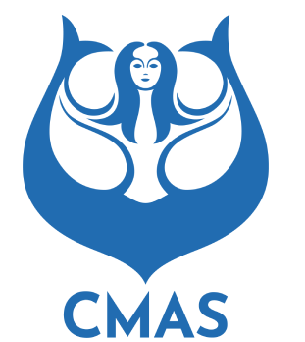
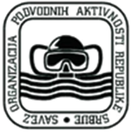

2024
CMAS 14th World Championship
Freediving Indoor
Seniors - Juniors - Masters
Belgrade - Serbia
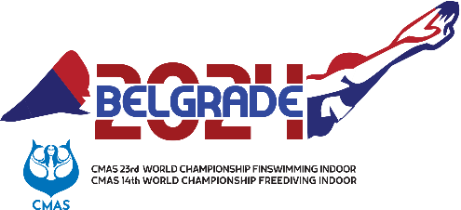
04-10/07/2024

Welcoming Addresses

MESSAGE FROM THE WORLD UNDERWATER FEDERATION PRESIDENT

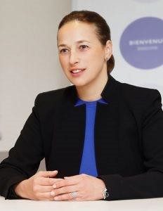

Anna Arzhanova
President, CMAS

It gives me great pleasure to welcome you to the city of Belgrade, Serbia. On behalf of CMAS, I would like to express our gratitude to the host city for sharing our passion for underwater sport and for their willingness and flexibility in hosting our biggest event.
Belgrade has a proven track record of hosting successful World events, I am confident that Belgrade will deliver outstanding competition for athletes and fans alike.
With eighteen months to go before the World Games in Chengdu, this will be an incredibly important time for athletes looking to earn qualification. The competition venue in Belgrade is ready to welcome more than 150 athletes from over 40 countries and provide them with the perfect conditions to compete.
I would like to express my sincere thanks to our partners, staff, officials, and volunteers for all their hard work and dedication in making this event possible. I have no doubt that these World Championships will be a historic event that will be remembered for many years to come.
I hope you will join me in cheering on the incredible athletic performances. I also hope you will take some time to experience the beautiful Serbian culture and warm hospitality during your stay.
To the athletes, please accept our best wishes for your competitions. We will be cheering you on from the stands, while working to provide the excellent conditions your hard work and talent merit!

MESSAGE FROM THE DIRECTOR GENERAL OF THE ORGANIZING COMMITTEE

Bozana Ostojic
President, Serbian Underwater Federation
Dear friends and colleagues,
It is my honour to welcome you to Serbia for the 2024 CMAS 14th World Championship Freediving Indoor.
As a proud Serbian and passionate member of the CMAS family, this is a very special moment for me, as well as my country.
Serbia has had the privilege of hosting a number of World CMAS events in the past. The World Championships is unique in bringing the best athletes from all over the world together in a celebration of our one sport. It reflects that we are one aquatics family, united through water.
We are grateful for the trust you have shown in awarding us the right to host these prestigious Championships. And we can assure you we will honour that trust with an exceptional event.
Belgrade 2024 has embraced innovation and creativity as we look to set new standards and stage the best ever World Championships. A sustainable, inclusive and outstanding World Championships which matches the excellence of our athletes.
We are so excited to join you in cheering on these incredible athletes and celebrating this event.

WELCOM E TO SERB IA
Welcome to SERBIA, the proud host of the 2024 CMAS World Championship Freediving Indoor, Belgrade.
Experience the essence of sporting excellence and unmatched hospitality as we gather in this vibrant nation to celebrate the pinnacle of mastery. Renowned for its world-class sports events, Serbia is ready to provide an extraordinary platform for athletes, officials, and spectators from across the globe.
Get ready to witness unparalleled feats of athleticism, immerse yourself in the breath-taking beauty of our modern cities, where tradition and innovation blend harmoniously.
Beyond the competition, immerse yourself in the captivating blend of tradition and modernity as you embark on an unforgettable journey to Serbia. This enchanting destination offers a multitude of experiences that will leave you spellbound and yearning for more.
Come and experience the enchantment of Serbia a land of captivating contrasts, where tradition meets innovation, and where warm hospitality and unparalleled experiences await. Create memories that will last a lifetime in this extraordinary destination.
Enjoy your unforgettable journey at the 2024 CMAS World Championship Freediving Indoor Belgrade in Serbia!

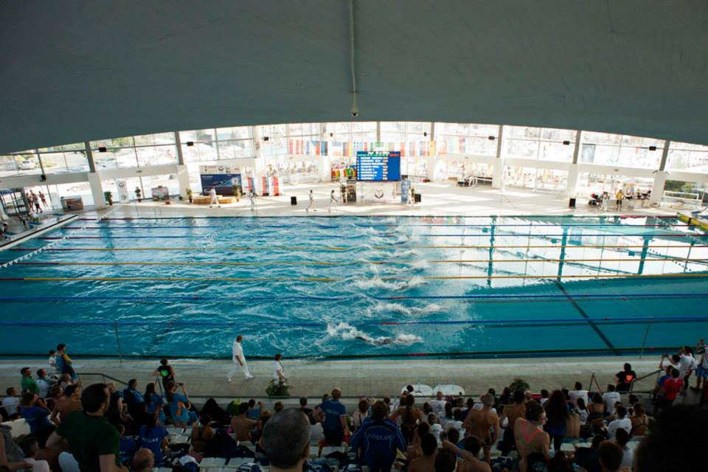
the Competition venue

The Championship will take place in Belgrade, Serbia from 4th to 10th July 2024 at SC 25 Maj Milan Gale Muskatirovic.
This venue is renowned for its ability to accommodate various sporting events.

Main Competition Pool #Indoor
Event: | Freediving
Seating capacity: | 750 (gross)
Area, Depth: | 50x21x2,1m
Number of Lanes: | 8
General Information

- Only participants with a CMAS license are eligible to compete in the Championship.

- All participants should respect the championship rules. The safety conditions set by the organizers and the CMAS rules and regulations.

• Each country may enter a maximum of 4 athletes per discipline/category/men/women.
• Entries must be submitted to CMAS headquarters within deadlines set by CMAS rules (details available at https://portal.cmas.org/login. Registration through SportsID – Sportdata).
• World Seniors Championship will occur over four competition days.
• World Juniors Championship will occur over the same competition days and same registration procedure through Sportsid.
• World Masters Championship will occur over the same competition days but Masters will apply for individual registration at Sportdata.
• Age Categories are as defined at the relevant CMAS freediving rules.
• National federations must send official performances of all selected athletes to organizing committee within three weeks post-competition, in one of the three CMAS languages. This allows verification of athlete’s enrolment row for championships.

SWIMMING POOL EVENTS:

Dynamic Apnea Without Fins DNF
Dynamic Apnea with Bi-fins (DYN-BF)
Dynamic Apnea DYN
Static Apnea STA
Speed Apnea 2x50m
Speed Apnea 4x50m
Speed Apnea 8x50

INTERNATIONAL JURY
CMAS Technical Delegate according to the CMAS rules.

PROTESTS
According to the CMAS rules.

DOPING CONTROL
Anti-doping tests may be conducted during the championship according to the international rules of WADA and the CMAS anti-doping code.
The organizing committee guarantees to provide doping control according to the CMAS and WADA rules.

General SCHEDULE

2024 CMAS 14th World Championship Freediving Indoor
Belgrade, Serbia
General Schedule as follows:

Day 1 | 4/07/2024: Arrival of Delegations
Day 2 | 5/07/2024: Training, Technical Meeting, Open Ceremony
Day 3 | 6/07/2024: 1st Day of competition
Day 4 | 7/07/2024: 2nd Day of competition
Day 5 | 8/07/2024: 3rd Day of competition
Day 6 | 9/07/2024: 4th Day of competition
Day 7 | 10/07/2024: Departure of Delegations

Competition SCHEDULE
PROGRAM

4 July Thursday Day 1
All Day Arrival and Check-in of Delegations

5 July Friday Day 2
09:00 14:00 Training (50m Pool)
13:00 16:00 lunch
16:00 17:00 Technical Meeting
18:00 19:30 Opening Ceremony

6 July Saturday Day 3
08:30 12:00 World Championship: Dynamic Apnea Without Fins
12.15 12.40 Medal Ceremony DNF
13:00 15:00 World Championship: Speed Apnea 8x50
15:00 15:30 Medal Ceremony Speed 8x50
13:00 16:00 lunch
17:30 19:00 Training (50m Pool)

7 July Sunday Day 4
08:30 13:00 World Championship: Dynamic Apnea with Bi-fins (DYN-BF)
13.15 13.45 Medal Ceremony DYNBF
14:00 15:00 World Championship: Speed Apnea 2x50m
15:00 15:30 Medal Ceremony Speed 2x50
13:30 16:00 lunch
17:30 19:00 Training (50m Pool)

8 July Monday Day 5
08:30 12:00 World Championship: Static Apnea (STA)
12:20 13:00 Medal Ceremony Static
13:30 14:30 World Championship: Speed Apnea 4x50m
14:30 15:00 Medal Ceremony Speed 4X50
13:30 16:00 lunch
17:30 19:00 Training (50m Pool)

9 July Tuesday Day 6
08:30 13:00 World Championship: Dynamic Apnea DYN
13:30 14:15 Medal ceremony
13:00 16:00 lunch
18:00 19:30 Closing Ceremony
21:00 00:00 Final Party

10 July Wednesday Day 7
Check-out and Departure of Delegations

ACCOMMODATION

BOOKING & ENTRY FEES

The Belgrade 2024 Organizing Committee is proud to introduce the official Team Accommodation Package for the 14th World Championship Freediving Indoor, 2024 Belgrade.

HOTEL ROYAL INN - 4 STARS
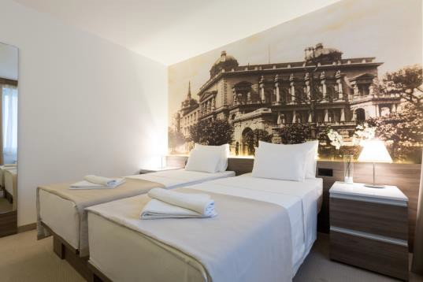
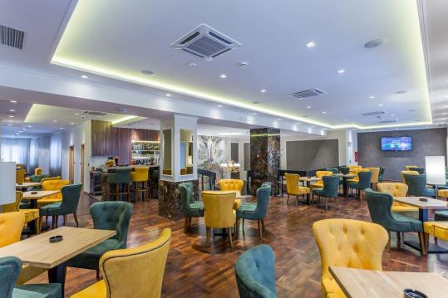
56 Kralja Petra Street, Belgrade. Royal Inn Hotel is located in the walking district of Belgrade centre, featuring standard rooms and suites.
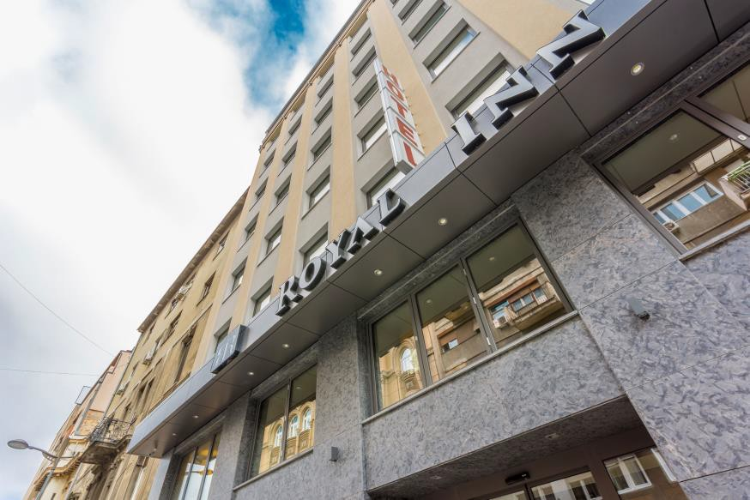

Distance Time
Nikola Tesla International Airport | 18 km | 20 minutes
25 Maj – Milan Gale Muskatirovic | 1,1 km | 5 minutes / 15 minutes walk

MONA PLAZA HOTEL - 4 STARS
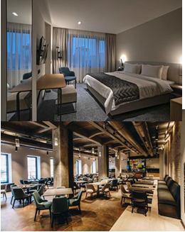
Located in Belgrade’s city centre. Mona Plaza comes with modern spacious rooms and suites.
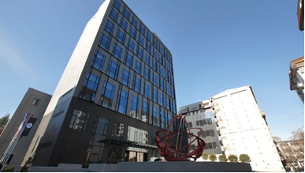

Distance Time
Nikola Tesla International Airport | 19 km | 25 minutes
25 Maj – Milan Gale Muskatirovic | 900 m | 3 minutes / 10 minutes walk

Team accommodation bookings will be completed on a first-come first served basis. Accommodation package for 6 nights – from 4th until 10th July are the following:

- Mona Plaza | - 1080 EUR
- Royal Inn | - 900 EUR

Each of the LOC Team Hotels has its own unique and enjoyable services and amenities nevertheless the LOC Hotels will include the following standards. Accommodation includes Full Board service for all rooms which include breakfast, lunch and dinner in times adjusted to team`s needs. Belgrade 2024 LOC is making every possible effort to ensure all participating athletes will receive the best dining & catering service, in whichever hotel they choose to stay. This will be achieved by offering a consistent menu and servicing times in all Team hotels. Further, Teams will have dedicated dining areas aiming to their comfort and privacy.

The package includes:
• Accommodation in 4*star hotels with double or triple hotel rooms full board
• 2x0,5 l drinking water per person, per day
• Free transfers between the hotel and the competition venue.
• Participation in the opening and closing ceremonies.

Extra day will be charged 170€ in Mona Plaza or 140€ in Royal In per pax per day. Including full board accommodation (breakfast, lunch, dinner).

Airport transfers both ways per person – 60 EUR

Extra charges:
• These payments must be organized directly with the organization of the Championship.
• Transfers from the airport to the hotel and return fee per participant is 60€.
• Extra charges for a single room is 30€ per person, per night in both hotels.

• All teams must stay during the Championship in the official hotels of the Championship. Participants who choose to be accommodated in hotels other than official ones will have to pay 500€ per person for Organizing Fees.

PAYMENT
Full amount should be transferred to LOC no later than 01/06/2024.

For accommodation inquiry and payment please contact LOC at wcbelgrade2024@gmail.com

After this date, the participation fees will increase by a further 10% of the total amount. The remaining payment should be paid upon arrival.

VISA
If you require a visa, please contact the organizing committee at least two months before entry.

DEADLINES FOR ENTRY AND PARTICIPATION

- Registration and payment of CMAS fees subscription
https://www.sportdata.org/cmas/set-online/veranstaltung_info_main.php?active_menu=calendar&vernr=159#a_eventhead

- No later than 10/05/2024:

- (Annex 1) The hotel booking form and entry fee should be sent to the Organizing Committee, together with a copy of the bank transfer.

- No later than 03/05/2024:

- Inform the Organizing Committee of your arrival details if you need a transfer to the hotel.

- No later than 10/06/2024:

DEADLINES
Registration entries must be entered online through, https://portal.cmas.org/login, SportsID and Sportdata.
Opening date of registration: 01/04/2024
Closing date of registration: 01/06/2024

For further information, please contact us at the following addresses:

- ORGANISING COMMITTEE:
- Bozana Ostojic, president of SRB Underwater Federation
wcbelgrade2024@gmail.com

