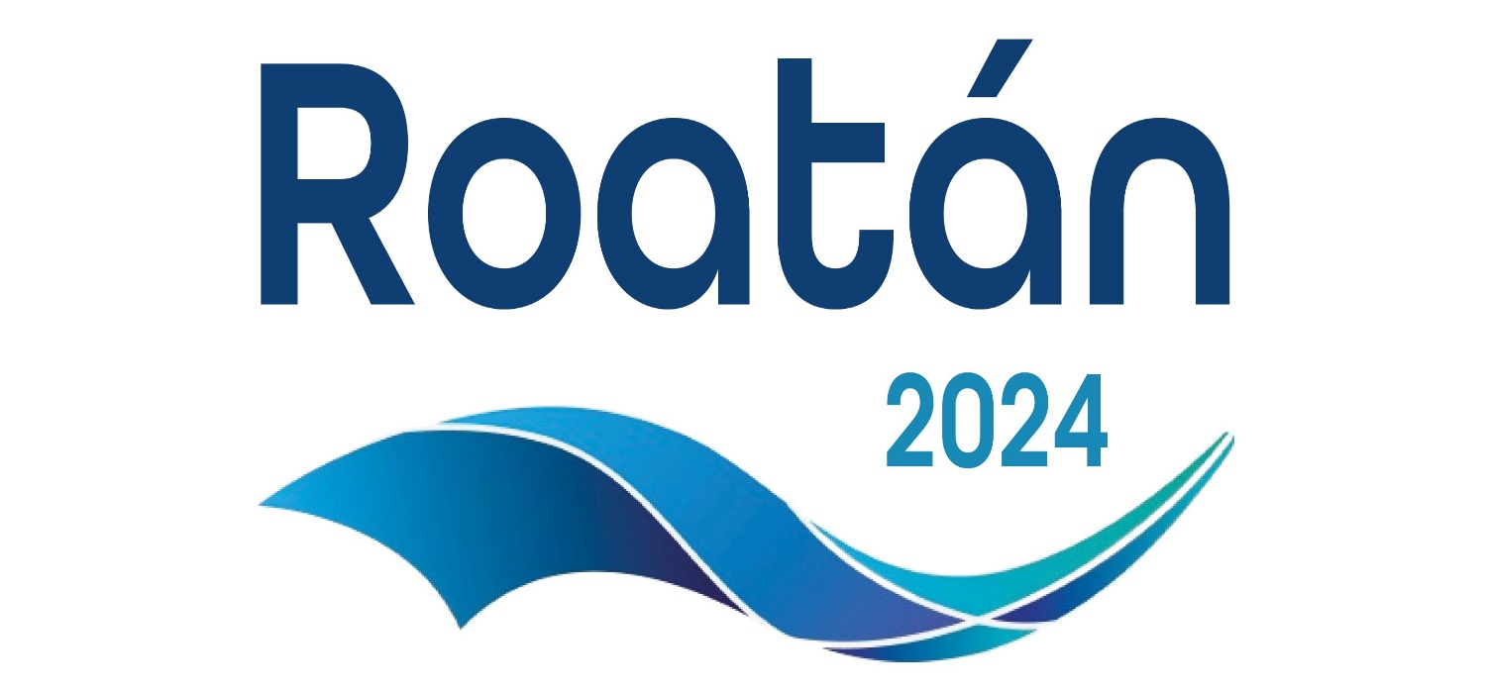

Organized by

The CMAS FREEDIVING WORLD CUP - DEPTH SERIES is envisioned as a premier CMAS worldwide freediving event that unites athletes from diverse cultures, backgrounds, and nations. The World Cup Depth Series will serve as a platform to promote freediving, promote global sportsmanship, and showcase the performance of athletes across various disciplines.
Roatan World Cup 2024 is a round of the CMAS FREEDIVING WORLD CUP - DEPTH SERIES

EVENT LOCATION
WEST BAY BEACH, Roatan Island, Honduras
West Bay is the beach where the event will take place. The diving platform will be located 3 minutes by boat from our headquarters, the “SAN SIMON BEACH CLUB” at MAYAN PRINCESS RESORT.
This Beach Club has opened their doors to the freediving community and allowed us to use the club as the event headquarters. At this venue, we will host the following amenities:
- Registration area and Office Space / WI-FI.
- Room for staff/helpers.
- Judges Room.
- Rorom for Event Committee.
- Safe storage/lockers.
- Showers and changing rooms.
- Full bar and restaurant.
- Lounge chairs and hammocks.

SCHEDULE
AUG 7th Meeting Event and Opening Ceremony.
AUG 8th Competition Day 1
AUG 9th Competition Day 2
AUG 10th Rest Day
AUG 11th Competition Day 3
AUG 12th Competition Day 4
AUG 13th Rest Day
AUG 14thCompetition Day 5 -
AUG 15thCompetition Day 6 - Awards Ceremony and Closing Party

For every Competition Day:
First TOP TIME 8:45 am
Ferry boat from San Simon Beach Club to competition site every 30 minutes from 8:00am.
Each competition day, athletes will be free to choose in which discipline to compete (FIM / CWT / CWT-BF / CNF).
The Freediving World Series will include the following events:
- Senior Male: CWT, CWTBF, CNF, FIM
- Senior Female: CWT, CWTBF, CNF, FIM
DIVE SITE
The site proposed for the competition is 0.70 m from shore (N 16° 16 ́ 577 ́ - W -86° 36 ́ 365´), located in front of West Bay Beach and within 3 minutes by boat from our headquarters at San Simon Beach Club.
Two moorings are permanently installed on a large sand patch, at a depth of 189 meters (620 feet). These moorings will then anchor the competition platforms and boats for athletes, staff, spectators and media.
MARINE INFRASTRUCTURE, PLATFORMS AND TRANSPORTATIONS
Two competition lines.
Queen Victoria is a newly built catamaran boat, 60 ft in length, 24 ft wide. This comfortable boat will be anchored and offer dry space in the competition area (shade, freshwater showers, bathrooms, bar) to athletes, staff, media, Diveye Team and spectators, who can also observe the athletes’ performances from surface with masks and snorkels in a specially delimited area.
A transfer boat with a capacity of up to 20 people will be permanently available to ferry competitors, judges and staff from shore to the competition catamaran. (3-minute boat ride).
One additional boat will be permanently by the dive platform for the exclusive use of emergency evacuation.
SAFETY
Six experienced, trained safety divers per competition line.
A doctor/medic on the platform per line.
Traditional counterbalance system capable of 2+m/s assisted ascent.
High resolution sonar.
A fully equipped ambulance on standby at our headquarters San Simon Beach Club, provided by "Alert International Rescue".
Emergency evacuation boat.
Medical clinic 200 meters from our headquarters San Simon Beach Club.
Advanced medical center and decompression chamber at 15-minute drive.
EXPECTED WEATHER CONDITIONS AUGUST 2023
Air Temperature
25 – 30 C (77 – 86 F)
Water Temperature
27 – 29 C (80 – 84 F)
Water temperature decreases about 2 degrees at 100 meters.
Currents
Null to moderate.
Visibility
24 – 40 meters (80 – 120 feet).

LOODING
Athletes are free to choose accommodation in accordance with their preferences and budget. Some Resorts, Hotels, Inns and Rental Houses in West Bay and West End will offer special prices.

WEST BAY BEACH
Paradise Beach Hotel http://paradisehotels.com/
Mayan Princess https://www.mayanprincess.com/
Naboo Resort & Dive Center, West Bay, Roatan https://nabooresort.com/
Buena Vista West Bay Roatan Vacation Condos http://buenavistaroatan.com/
Bananarama Dive & Beach Resort https://bananarama.com/

WEST END TOWN
West End Town is a mere 10 minutes away from West Bay, by taxi boat or car (that run continuously until dark)
Lands End Roatan https://landsendroatan.com/
Luna Beach RESORT https://lunabeach.net/
Half Moon Bay Resort - West End Bay Islands Hotel & Dive https://roatanhalfmoon.com/
Splash Inn https://roatansplashinn.com/
Mariposa Lodge https://www.mariposa-lodge.com/
Coconut Tree Cabins https://www.coconuttreecabinsroatan.com/

Registration:
Registration fee cost: USD 700
A limited number of 60 participants per event will be registered in the basis of first come first registered.
Registration will be online in Sport data. Seniors Category only.
https://www.sportdata.org/cmas/set-online/index.php
Online license will be applied with cost 24 euro per participant.

Additional training
Roatan Freediving School & Training Center offers daily training all year round.
Training fee:
1 to 4 sessions USD 40
5 to 9 sessions USD 35
10 or more USD 30

Rules:
The relevant CMAS rules and regulations for each discipline. Specific rules for the Depth Series will be also applied.

Roatan World Cup 2024 is a World Record Status competition.

Anti-Doping Control
The International Testing Agency (ITA) decide the testing plan of the competition and send it to LOC.

Scoring and Classification System:

CWT: 1 point per meter.
CWTBIFINS: 1 point per meter.
FIM: 1 point per meter.
CNF: 1.25 points per meter.

Event medals
3 first places for men and women in each discipline.
Overall winner of each WORLD CUP round.
There will be an overall ranking for each round as follows:
The athlete with the best sum, adding points from his best performances, from all 4 discipline or from less if he has not participated at all disciplines.
Even If an athlete has not participated at all events, his total score counts at the event ranking.
e.g
CWT:100 mt=100 points
CWTBIFINS:95 mt =95 points
FIM:100 mt =100 points
CNF: 80mtx1,25= 100 points
Total 395 points

- Total CMAS WORLD CUP DEPTH SERIES Classification:
Calculating Total Points:
For each participant, adding the total points earned in their two best events.
Overall, Winner of the CMAS FREEDIVING WORLD CUP DEPTH SERIES:
The athlete with the highest total points based on his best two events is declared the overall DEPTH SERIES Winner.

CONTACT PERSON
Esteban Darhanpe, organizer
E‐mail: info@roatanfreediving.com
WhatsApp +504 8854 1171
http://roatanfreediving.com

